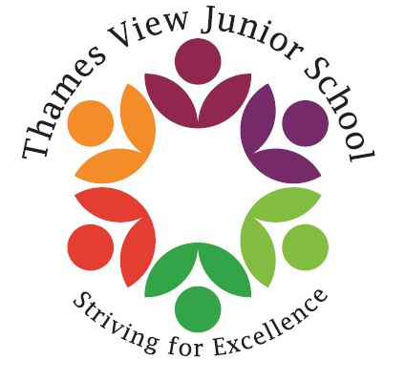
Headteacher: Sara Rider
Assistant Headteachers:
Hans Ramduth, Rebecca Seaton,
Rachel Mottershead,
Georgina Nixon.

Wednesday 16th May 2018
Dear Parents/Carers,
Next half term, I will be running a Money Matters Club for children in Year 6. As they move up to secondary school, it is important they can use money, budget, save and handle a bank account. We will also deal with scams related to money. The club will be on Thursdays, 3-4pm. If your child is interested, please return the form below by Monday 21st May. I am also aware that in the current situation where many of us face workplace cuts and austerity measures, we could all use some help in managing our finances. If you would also be interested in a parents’ one-off session, please indicate this on the form and I will arrange one.
Yours faithfully,
Rebecca Seaton
Assistant headteacher, Stakeholder and Community Engagement

Please complete the form and return to Miss Seaton or the office.

Child’s Name: ______________________ Class: ___________________

Parent/ Carer’s name:_____________________________

Phone number: __________________________________

My child will be collected from school/walk home alone.

I would/would not be interested in a parents’ Money Matters session

Signed: ________________________ Date: ______________

