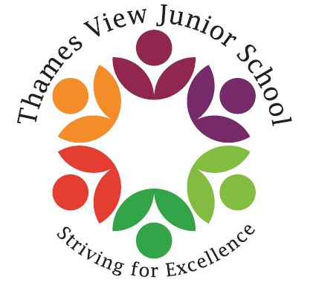

Headteacher: Sara Rider
Assistant Headteachers:
Hans Ramduth, Rebecca Seaton,
Rachel Mottershead,
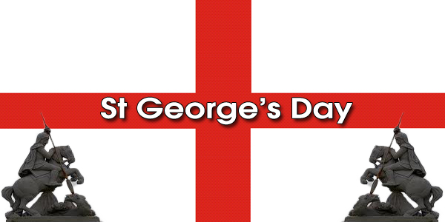
Georgina Nixon

Dear Parents,
Welcome back to the Summer Term! The good weather has finally arrived and I am hoping it is here to stay!
It was great to see all the children back in school and some of them look so much bigger than 2 weeks ago! A huge well done to our wonderful year 6 children who came into school during their holidays for SATs boosters and a special thank you to the teachers who gave up their time to come in and work with the children.
This term, things start to get very busy and active. There will be lots of events going on and we will need your involvement.
Please watch out for my newsletter next week with more information about the upcoming events.
In the meantime, we are going to be celebrating St Georges Day on Monday. We are encouraging the children to dress up in red and white and donate £1 which will go towards an end of Summer school celebration. So the more we can raise the better!
Have a wonderful end to the week and weekend!
Best Wishes,

Sara

