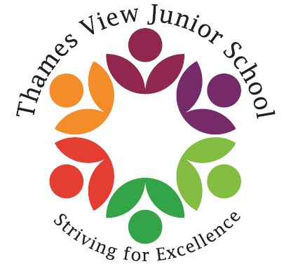

Headteacher: Sara Rider
Assistant Headteachers:
Hans Ramduth, Rebecca Seaton,
Rachel Mottershead,
Georgina Nixon

Tuesday 1st May 2018

Dear Parents,
Firstly a huge welcome to Thames View Junior School. I am looking forward to meeting you and your children over the coming months and welcoming you into our school.
For many of you, the transition from Infant to junior school can be quite an anxious time, you will probably have many questions about our curriculum, the teachers and our expectations. Over the coming weeks, we will be working closely with the Year 2 team at Thames View Infants to get to know the children and will be developing a detailed transition plan to support the move from Year 2 into Year 3.
The teachers from Thames View Juniors will be visiting the children after half term and will be teaching the children later on in the year. Your children will also have the opportunity to spend the morning here in their new classes in July. All of these things help to support and comfort the children through the transition and make it as smooth as possible.
As many of you will know, in January we had our Ofsted inspection. The school improved in all areas from our previous inspection and has moved from special measures to Requires Improvement with the behaviour and personal development being judged as good. We continue to firmly believe, as do our academy trust and governors that we are moving rapidly to becoming a good school and have all of the attributes required to do so.
Last year, the school achieved our best ever SATs results at the end of KS2. We were the most improved school in the borough. Our results were well above national averages and we continue to improve. We set very high expectations of our children and expect them to achieve and reach their capabilities.
We have completely redesigned our curriculum to ensure that it is broad and allows the children to experience a range of deep and meaningful subjects. We aim to take the children on trips half termly to support their learning. We also have a range of people visit our school to work with and perform for the children.
I firmly believe and often say to all prospective parents, come and see our school and see what we do. It truly is a wonderful place with happy children and staff and as the Headteacher I am both passionate and committed to the school and its ongoing development.
Therefore, I would like to take this opportunity to invite your into school for an open morning. I will personally take you on a tour of the school, answer any questions you may have and show you what a normal morning looks like here at Thames View Juniors. I will then meet with you again in July to introduce you to the Year 3 team.
The dates for the open mornings are: Tuesday 22nd May 9.30- 10.45 and Wednesday 23rd May 9.30-10.45.
I really hope to see you there and looking forward to meeting and getting to know you over the coming months.
If you have any questions at all, please do not hesitate to drop into school or call me. I am always happy to speak to you.

Best Wishes,

Sara Rider
Headteacher

