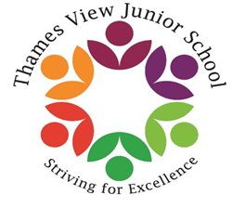
Headteacher: Sara Rider
Assistant Headteachers: Hans Ramduth, Rebecca Seaton,Rachel Mottershead & Georgina Nixon
Monday 19th February 2018
Dear Parents and Carers,
Due to school being closed before half term, we have rescheduled some events for Year 3 children.
Our Romans Topic presentation will now be Thursday 22nd February in the hall at 2:00pm. Parents, carers and family members are welcome to attend. Could children please bring an old pillow case (we will cut a hole in it) or alternatively a sheet, plain white t-shirt or anything else that looks ‘Roman’.
Trips to the Guildhall Roman Ampitheatre have been rescheduled for the following dates:
Fir and Holly Class on Tuesday 20th March.
Ash Class on Monday 26th of March.
We will order the school packed lunches that parents requested on the permission form. If you would like to change your lunch request, please let the class teacher know.
Thank you,
Year 3 Teachers

