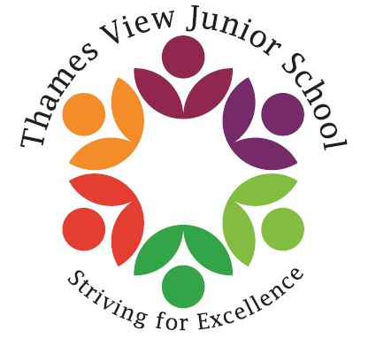
Headteacher: Sara Rider
Assistant Headteachers:
Hans Ramduth, Rebecca Seaton,
Rachel Mottershead,
Georgina Nixon.

Monday 12th March 2018
Dear Parents/Carers,
As you are aware, your child will be taking their Year 6 SATs (Statutory Assessment Tests) between Monday 14th May and Thursday 17th May 2018.
With this in mind, a number of teachers have volunteered to donate their own time to help the children prepare further for their SATs over the Easter holidays. It would be incredibly beneficial if your child could attend these three days of boosters during the second week of the Easter holidays. These boosters will run on Tuesday 10th, Wednesday 11th and Thursday 12th of April from 9am to 11:30am. This will allow the children to focus on Reading and Maths, as these have been identified as areas for development after our last set of assessments.
I would especially like to encourage those children who already attend our weekly boosters, as these children have been our targeted children and have already benefitted from these sessions. There will be more information to follow for those children who agree to attend.
Yours faithfully,
Miss Nixon.
Please complete the following by ticking the box which applies to your child and return to their teacher.

Child’s Name: ______________________ Class: ___________________

My child will be attending the above lessons.
OR
My child will not be attending the above lessons.

My child will be collected from the school office after the above lessons.
OR
My child will go home on their own after the above lessons.

Signed: ________________________ Date: ______________

