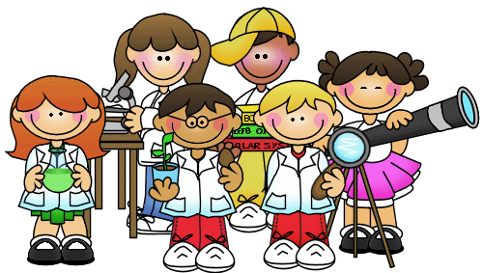
Inventors and Light and Shadow Projects
Our topic this half term is Inventors. In Science we will be learning about Light and Shadows. During this half term, you should complete at least two of the following projects and give them to your teacher.
Research a famous inventor and write a report eg. Thomas Edison, Leonardo Da Vinci | Draw a sketch or labelled diagram of one form of transport eg. car, train, bus, bicycle | Draw/paint a rainbow with the colours in the correct order.
Make a timeline showing how an invention has changed eg. telephones, computers, cars, bicycles | Design a new fabric cover for seats on the London underground. | Write a poem about rainbows describing each colour.
Draw a design of a machine/robot that could tidy your room. | Design a poster for the underground – What message will it give to travellers? | Describe and draw what happens when you write a word on a piece of paper and then look at it in a mirror.
Design and make a shadow puppet including some translucent and some opaque material. (If you are not sure what this means, look on the BBC schools website) | Make your own sundial. Set it up outside and evaluate how well it works. You could use this website to help www.metoffice.gov.uk/education/ki ds/weather_experiments_sundial.ht ml | Think of your own idea for a project about Inventors or Light and Shadows.

