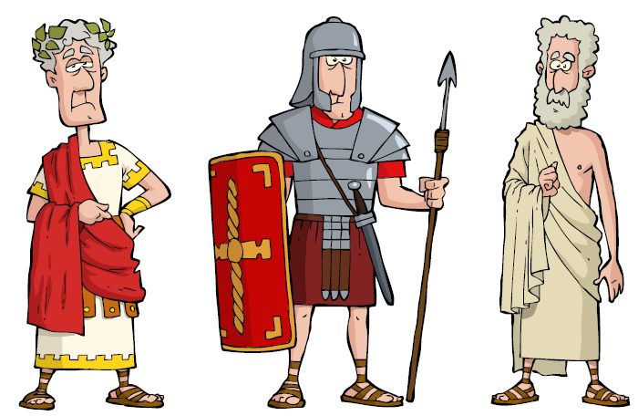
Romans Projects
Our topic this half term is Romans. During this half term, you should complete at least two of the following projects and give them to your teacher.
Write the numbers 1 – 30 using Roman Numerals. | Create a book about one or several Roman gods with a contents page, page numbers and a cover | Write a description of Boudicca. What was she like?
Design and make a clock using Roman numerals. | Design and make your own piece of Roman jewellery or pottery. | Design your own mosaic.
Imagine that you are a Roman temple builder. Design and make a model of a temple to a god of your choice. | Create a poster about a Roman God. | Make a tourist leaflet about things to do in Rome.
Design and make a Roman shield or helmet. | Find out about schools in Ancient Rome and write a report. | Create your own map of the Roman empire.

