Homework – Spring 1 - Week 1
Friday 5th January

Spelling | 1 | 2 | 3 | 4
Likely
Straight
Sensation
Nervous
Crumb
Probable
Inspiring
Substance
Operation
Toughest
Writing: Write two diary entries about your Christmas holidays.
Grammar:
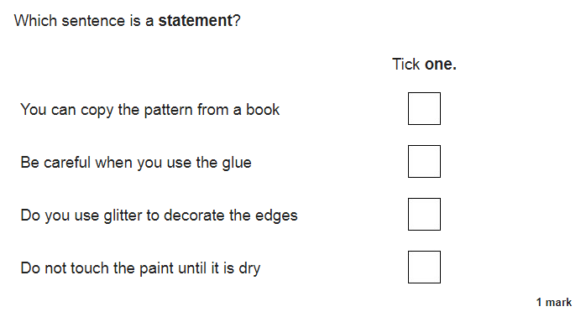
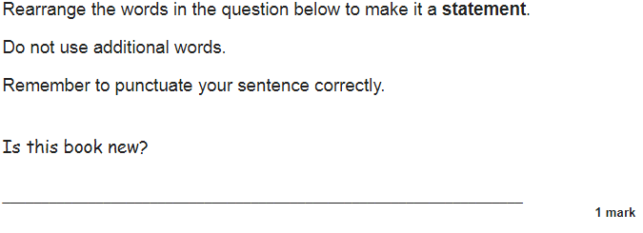
Maths: Complete the worksheet on rotation.

