Homework Spruce class – Week 2
Friday 12th January 2018

Spelling | 1 | 2 | 3 | 4
available
average
awkward
bargain
bruise
category
cemetery
committee
communicate
community

Write a sentence with each one of the spelling words:
1.___________________________________________________________________________________________________________________________________________________
2.__________________________________________________________________________________________________________________________________________________
3.__________________________________________________________________________________________________________________________________________________
4.__________________________________________________________________________________________________________________________________________________
5.__________________________________________________________________________________________________________________________________________________
6.__________________________________________________________________________________________________________________________________________________
7. ________________________________________________________________________________________________________________________________________________
8.__________________________________________________________________________________________________________________________________________________
9.__________________________________________________________________________________________________________________________________________________
10._________________________________________________________________________________________________________________________________________________

Q1.
200 girls and 100 boys were asked about their favourite meal.
These pie charts show the results.

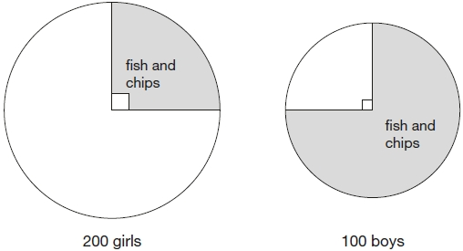

Look at the pie charts.
For each statement put a tick (✔) if it is true or a cross (✘) if it is false.

Three-quarters of the boys chose fish and chips.
Three times as many boys as girls chose fish and chips.
Altogether, half of the children chose fish and chips.
25 more boys than girls chose fish and chips.

Q2.
This graph shows how the temperature changed in Liam’s room one afternoon.

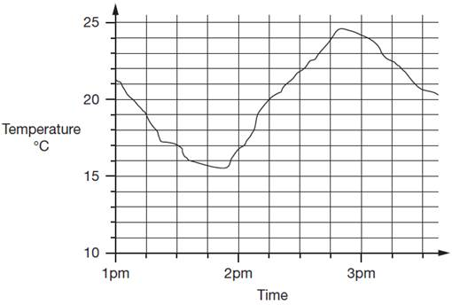
Estimate the temperature at 3:15pm.

Estimate the time when the temperature was highest.

How much did the temperature change from 2pm to 2:30pm? Give your answer to the nearest degree.
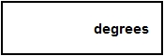

Q3.
These are the opening times at Black Tower Castle.

 | Monday | Closed
 | Tuesday to Friday | 11am to 6:30pm
 | Saturday | 10am to 6pm
 | Sunday | 10:30am to 4:30pm

How many hours is the castle open on Saturdays?
Alfie arrived at the castle at 5pm on a Thursday.
How long could he stay before closing time?

This chart shows the favourite snacks of some boys and girls.

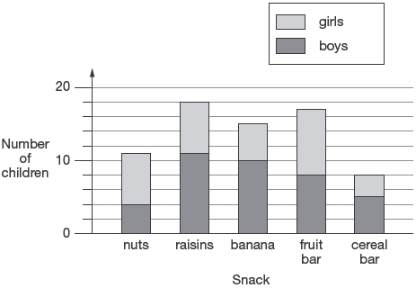
How many snacks were chosen by more girls than boys?

