Behaviour Policy
Behaviour and Engagement Policy

September: 2022
Review: July 2024

Mission Statement

- The ethos of our school is to promote good behaviour via a calm well structured environment that consists of a safe learning atmosphere in which every person is valued.
- We aim to promote a positive attitude in our pupils, creating an environment in which good behaviour is expected, within a climate of trust. We see this as a three-way partnership with pupils, parents and staff all taking responsibility for their actions.
- Thames View Junior School is a school with a strong moral ethos. School rules are for the safety and comfort of all members of the school community as well as a way of establishing social learning. Any form of bullying, discriminatory behaviour or fighting will not be tolerated.
- At Thames View Junior School we have adopted the ‘Class Dojo’ initiative. The Class Dojo system provides expectations which focus on positive action (be respectful) rather than what pupils should not do, it highlights both good and bad behaviour with appropriate actions in order to promote well rounded students. The expectations are agreed actions so that there is consistency and fairness in all areas of school life. However, as an inclusive school, we recognise that all pupils are individuals with specific needs. Therefore, within this consistent approach is an element of flexibility to address the needs of specific pupils. Behaviours must be put in context and require all staff to use their professional judgement.

At Thames View Junior School, we have 3 rules:
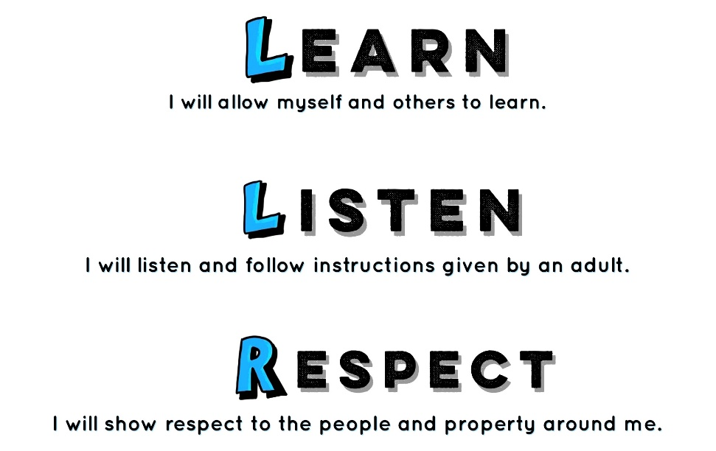

Rationale
At Thames View Junior School we believe that the behaviour policy should support and develop the rights and responsibilities of the pupils and adults within the school, emphasise that its successful execution depends on everyone’s support, and that it will ultimately benefit all in the school community. The overriding aim should be to encourage self-discipline and self-awareness in the pupils.
Purpose
- To develop habits of self-discipline and acceptable behaviour;
- To develop self-respect;
- To develop respect of, and sensitivity to, others;
- To develop co-operation;
- To develop respect of property, their own and other people’s.
Aims of the Policy
- That every member of our school community feels valued and respected;
- That we promote an environment where everyone feels happy, safe and secure;
- That every member of our school community is treated fairly and in a consistent manner.

How Positive Behaviour is taught through the curriculum.
- Positive Behaviour is taught through the PSHE curriculum.
- Positive Behaviour is addressed during assemblies.
- Positive Behaviour forms an important part of the SMSC lessons.
- Positive Behaviour, on a smaller more intimate scale, is taught during Social Skills Groups.
- Positive behaviour is rewarded through class dojos.

Values

As a school we will follow the values-based approach to learning which seeks to promote an educational philosophy based on valuing self, others and the environment. It helps children to develop holistically, nurturing a secure sense of self, respect for self and others and supports our ethos and school vision.

Every fortnight, whole school community will work on a key value together. Staff will praise the children via Class dojos who follow these values and encourage the children who need support to reach their value goals. Each week, the whole school assembly will also highlight the importance of the fortnightly focused value. The value of each week is stipulated on the assembly overview for each term.

Rights and Responsibilities
As a school community at Thames View Junior School (pupils, all school staff and parents/carers) we all have rights but accept that we all have responsibilities.
Pupils's Rights and Responsibilities
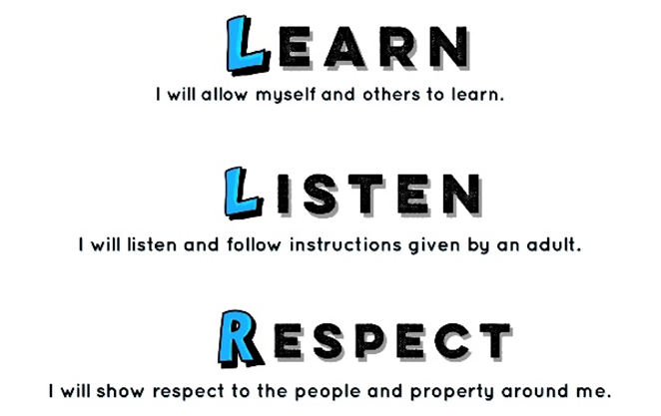
Pupils have the right to a good education, to be happy and healthy, to join in lots of activities and to express their opinion. They are responsible for their own behaviour and for meeting the expectations set out by the school. They will:

Follow the school’s behaviour expectations and earn Class Dojo points.

Staff Rights and Responsibilities
All staff have the right to provide a good education for all pupils in a happy, safe environment. They have a collegiate responsibility for consistently implementing school policy on positive behaviour. The Headteacher holds overall responsibility.
All staff will:
- treat all pupils fairly and with respect,
- provide a challenging and stimulating curriculum,
- create a safe and pleasant learning environment,
- recognize each child’s individuality and be aware of his/her needs,
- teach pupils the rules and make expectations clear,
- use rules and sanctions clearly and consistently,
- work together with parents, carers, colleagues and other agencies,
- be good role models to the pupils in their care.
- Log into Class Dojo every morning for ease of access throughout the day.
- Use Class Dojo to showcase children’s work.
- Use Class Dojo as a platform to communicate key messages relating to the class.
- Complete a dojo log every Friday and reset ‘bubbles’ ready for the following week.

Parents Rights and Responsibilities:
All parents/carers have the right to know that their child is being well educated in a safe environment. They also have the right to be listened to, made aware of any problems affecting their child’s behaviour and to be supported and guided in dealing with their child’s behavioural issues.
All parents will:
- Treat all pupils and adults fairly and with respect.
- Support the school in the implementation of this policy and attending any scheduled meetings to address behaviour issues.
- Be aware of the school rules.
- Show an interest in all their child does while at school.
- Encourage independence and self-discipline.
- Be a good role model to their child.
- Make the school aware of any information which may result in their child displaying behaviours outside the norm.
- Log onto Class Dojo everyday for any key messages and to see their child’s work.

PROCEDURES FOR DEALING WITH PUPILS’S BEHAVIOUR
Achievement- Dojos

Each class will use class dojo to positively reward children in their work, attitude and movement around the school. The following Green dojos should exclusively be used for each class:
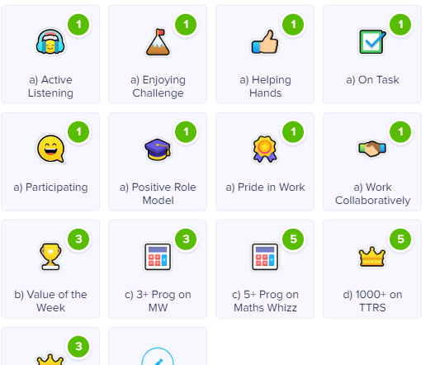

- Every Thursday from after school, class teachers will record the total number of dojos each child in the class has achieved onto an internal tracker. Every teacher will also refresh their dojo dashboard for a new start Friday morning.
- All teachers to add the names of the Dojo King & Dojo Queen to the whole school assembly powerpoint (Appendix 2).
- The whole school assembly powerpoint to also include star of the week (child also given a certificate), Class for the week for achieving the highest progression points and finally Class for the week for achieving the highest progression points for Lexia.

- During celebration assembly every Friday, certificates will be presented to every boy and girl from each class who has achieved the highest number of dojos (Dojo King & Dojo Queen- see appendix 1).
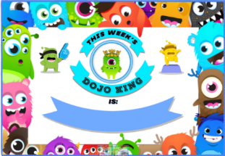
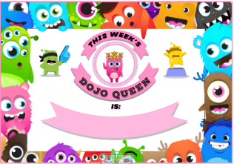

- Every class will have a display to showcase the dojo dashboard, along with the shopping list which children are aiming for. The display will also showcase ‘this week’s dojo & dojo queen’.
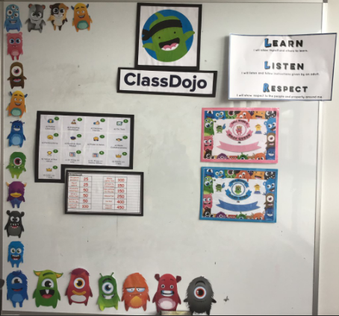
*A3 size LLR poster (laminated)
*Class dojo title (laminated)
*Dojo King & Queen Certificates (laminated)
*Class dojo Dashboard A3 size printed and laminated.
*Class dojo shopping list printed A3 size (laminated)
*Class dojo characters printed and laminated A4 size.

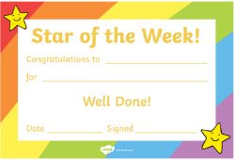
- Every Friday there will also be a ‘Star of the week’ certificate award to a child from every class.

(Appendix 3- see overview of the positive rewards protocol)

Dojo Shopping list
Each class will have a Dojo Shopping list which features a price list of rewards that the children can purchase with their Class Dojo points. The rewards on the shopping list are weighted and can be ‘spent’ half termly. Once Dojo’s have been ‘spent’ on a reward, they will minus from the child’s total. The children can access their totals on the class Dojo Excel sheet and this can be used as an incentive and motivator to focus on achieving the points.

Assemblies
Monday- value assembly led by the Headteacher (SLT member in the absence of the Headteacher).
Wednesday- singing assembly- on a fortnightly basis lower school and upper school will participate in singing assemblies, led by the music lead.
Friday- Achievement assemblies. These assemblies will be led by all staff, on a rota. Each week all teachers must contribute towards the assembly power point which celebrates the children who have achieved: -
- Highest number of dojos (Dojo King & Dojo Queen)
- Star of the week
- Classes with the most progression points with Maths Whizz and lexia will be awarded with a whole class trophy.

Wow Dojos Points
Wow Dojo points are whole class dojo points given by SLT only. They are awarded for exceptional whole class conduct and learning behaviours. At the end of each term, the class with the highest Wow Dojo points will take part in an extracurricular activity with a member of SLT.

Managing unwanted behaviours
Unwanted behaviour creates a barrier to learning and thus impacts on achievement. At Thames View School, teachers manage behaviour of pupils in and around the school, address any inappropriate behaviours and refer serious incidents as appropriate.

When dealing with inappropriate behaviour, all staff:
• encourage, praise and positively reinforce good relationships as a way of reinforcing the behaviour you would like to see rather than focusing on the negative behaviour.
• remain calm and avoid shouting at children
• avoid telling a child off publicly
• avoid all physical contact with children unless a positive handling plan is agreed and in place.
• aim to be good role models - punctual, well prepared, organised, polite and courteous
• support each other in addressing an individual child's behaviour needs and the needs of the whole school
• challenge all conduct involving bullying or harassment
• avoid whole-group sanctions that punish the innocent as well as the guilty wherever possible, use sanctions that are a logical consequence of the pupil's inappropriate behaviour
• ensure that sanctions are seen as inevitable and consistent
• always link the concept of sanctions to the concept of choice, so that pupils see the connection between their own behaviour, and its impact on themselves and others, and so increasingly take responsibility for their own behaviour.
• use PSHE lessons to enable children to express their feelings appropriately and to learn how to resolve conflicts through discussion.
• consider, when using sanctions, whether an apparent behaviour difficulty is in fact a manifestation of unidentified learning difficulties or other type of additional learning need; this includes consideration of whether the learning is differentiated and appropriate.

Red Class Dojo points
Red class dojos will be given when children do not make the right choices and display an unwanted behaviour. Red dojo points do not minus from the green positive dojo points. Red Dojo points will be reset at the end of each week. After a certain amount of red dojo points have been reached, the following consequences will be in place: (Appendix 4 for summary of below)

Number of Reds | What we do now
5 | - 5 minutes of play missed (CT)  - Parent to be verbally informed by CT.  - CT to log the accumulation of 5 dojos on CPOMS.
10 | - Whole playtime missed (CT)  - CT to set up meeting with Parent & YGL.  - CT to log the accumulation of 10 dojos on CPOMS.
20 | - Whole lunchtime missed with SLT. (CT to inform SLT).  - CT, SLT and SENDCO to meet with parents and inform parents of child going onto a behaviour modification report.  - SENDCo to determine whether child should be included on the SEND provision list as SEMH due to behaviour proving to be a barrier to progress.  - SENDCo to undertake a SNAP behaviour assessment.  - CT to log the accumulation of 20 dojos on CPOMS.
30 | - Behaviour lead to conduct observation of child in class and break times.  - Continue to monitor behaviour modification report.  - Inclusion lead to request dowry funding for additional 121 support.  - Meeting with safeguarding team and inclusion team to discuss further tailor made support strategies.
40 | - Internal or fixed term exclusion- to be decided by SLT.

Team points/ Dojo points
Every child across the school is assigned to a house captain:-Michelle Obama, Greta Thunberg, Marcus Rashford and Nelson Mandela. Every dojo point which is awarded forms points towards the house captains. Each term the House captains who achieve the highest number of dojo points achieve a non-uniform day.

Peer on Peer Abuse
In most instances, the conduct of pupils towards each other will be covered by our behaviour policy. However, some allegations may be of such a serious nature that they may raise safeguarding concerns.
Behaviour concerns of a more serious nature (as outlined below) must be reported on CPOMS to alert the safeguarding team.
- Domestic abuse – an incident or pattern of actual or threatened acts of physical, sexual, financial and/or emotional abuse, perpetrated by an adolescent against a current or former dating partner regardless of gen-der or sexuality.
- Child Sexual Exploitation – children under the age of 18 may be sexually abused in the context of exploitative relationships, contexts and situations by peers who are also under 18.
- Harmful Sexual Behaviour/Sexual Violence – Children and young people presenting with sexual behaviours that are outside of developmentally ‘normative’ parameters and harmful to themselves and others. This should be reported on CPOMS. For further information around HSB & Sexual Violence please see safeguarding policy.
- Serious Youth Violence – Any offence of most serious violence or weapon enabled crime, where the victim is aged 1-19 i.e. murder, manslaughter, rape, wounding with intent and causing grievous bodily harm. ‘Youth violence’ is de-fined in the same way, but also includes assault with injury offences.
- E-Safety concerns relating to Peer on Peer. Children may have unlimited and unrestricted access to the internet via a host of devices. This access can lead to a number of safeguarding issues that can be prevented while in school as well as dealt with appropriately when disclosed. There is a mobile device policy in place for the school that restricts the use and access of these devices during the school day. The school recognises that a host of issues can arise as a result of these devices relating to peer on peer concerns. These incidents could include harassment. Sexual or other, indecent image sharing (consensual or otherwise). We manage these risk by having clear safeguarding protocols to follow and when a child uses the school’s network to access the internet, they are protected from inappropriate content by our filtering and monitoring systems.
- There are also different gender issues that can be prevalent when dealing with peer on peer abuse (i.e. girls being sexually touched or/and assaulted or boys being subjected to initiation and/or hazing type violence).

Lunchtime Procedures/ Middays
Poor behaviour incidences occurring during lunch time should be documented by Middays. Middays are expected to complete the behaviour tracking documents and hand them directly to the class teachers after lunch time has ended. This is also tracked via the ‘lunch time behaviour’ folder, located behind the front office. Teachers are then expected to transfer the information onto CPOMS. Middays should also seek positive behaviour displayed by the pupils and reward the pupils with dojo points.

Exclusions
In most cases exclusion will be the last resort after a range of measures have been tried to improve the pupil’s behaviour. Exclusion will only be considered where the educational entitlement and the wellbeing and safety of the pupil concerned, the staff and the rest of the pupils in the class/school is jeopardised. The formal reasons whereby the school may consider the exclusion of a pupil would be: In response to serious breaches of the Behaviour and Engagement Policy
If, by allowing the pupil to remain in school, the education or welfare of the pupil or others in the school would be seriously harmed.
Where exclusion is necessary we refer to “Exclusion from maintained schools, academies and pupil referral units in England for Governing Boards and Headteachers” Factors to consider before making a decision to exclude:
• Ensure that a thorough investigation has been carried out.
• Consider all the evidence available to support the allegations, taking account of the school’s Behaviour and Engagement policy, where applicable, the Race Relations Act 1976 as amended and the Disability Discrimination Act 1995 as amended.
• Allow the pupil to give his or her version of events.
• Check whether the incident may have been provoked, for example by bullying, including homophobic or other prejudiced based bullying, or by racial or sexual harassment.
If necessary, consult others, but not anyone who may later have a role in reviewing the Headteacher’s decision, for example a member of the Governing Body.
Internal Exclusion
At the discretion of SLT and family, an agreement can be made for internal exclusion under special circumstances. Throughout the internal exclusion the pupil will remain under the supervision of SLT.
Lunchtime Exclusions
Pupils whose behaviour at lunchtime is disruptive may be excluded from the school premises for the duration of the lunchtime period. Lunch time exclusions will have agreed timings with the parents.

Racist Incidents
In accordance with the borough procedures all racist incidents should be reported to a senior member of staff. This includes verbal and physical insults related to race or religion. These are then reported to the borough.

Challenging Behaviour:
Pupils with emotional, social and behavioural difficulties will often persistently challenge class and playground rules to such an extent that in serious cases a Pastoral Support Plan may be required and a behaviour action plan completed and shared with members of staff.
If a pupil’s behaviour is not improved by the consistent use of rewards and sanctions listed in the school Behaviour and Engagement policy, then it is possible they have a special need. Consultation with the Leadership Team can lead to advice on the use of more specific techniques. If little or no progress is made, then an individual education plan will be required
Individual Pastoral Support Plans
Where a pupils’ behaviour is consistently challenging to the extent that the educational entitlement and/or health and safety of the pupil themselves or their peers is jeopardised, the Social Inclusion Officer, Headteacher and class teacher will develop a Pastoral Support Plan in consultation with parents/carers. The plan is set for a fixed period of no more than 16 school weeks at the end of which a review is held and a decision is made as to whether the plan has been successful. If the Pastoral Support Plan is not successful it is possible that the pupil may be excluded.
Pupils with Disabilities
We have a legal duty under the Disability Discrimination Act 1995 not to discriminate against disabled pupils by excluding them from school because of behaviour caused by their disability.
Race Relations
We have a legal duty to take steps to ensure that we will not discriminate against pupils on racial grounds when making a decision about whether to exclude a pupil.
Pupils in Public Care
We should try every practicable means to maintain pupils in Public Care in school.

Procedures for Review and Appeal
The Governing Body must review all permanent exclusions and fixed period exclusions that result in a pupil being excluded for more than 15 school days in any one term. They must decide whether or not to reinstate the pupil, if appropriate, or whether the Headteacher’s decision to exclude the pupil was justified.
At all times we wish to reinforce positive behaviour in our pupils.
Where inappropriate behaviour recurs repeatedly and records show no improvement, a programme of behaviour management strategies will be devised in conjunction with the SENDCO team, the pupil and the pupils’ parents/carers. If deemed necessary, outside agencies will be invited to contribute.
Physical Restraint
Where physical restraint is necessary, we refer to the School’s Positive Handling Policy.
This policy is brought to the attention of all parents annually.
A Positive Handling plan will be made after the first physical restraint incident.

Appendix 1 King Dojo King ,Queen & Star of the week Certificates

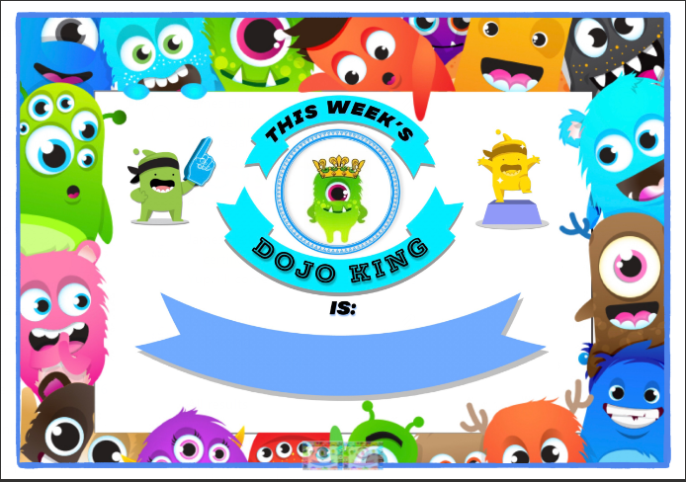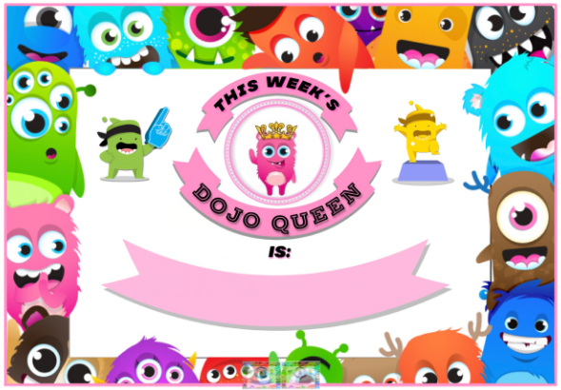

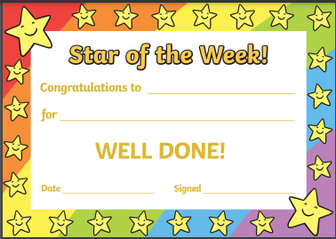

Appendix 2- reward assembly –whole school power point. (Saved on Share point :- Assemblies folder)
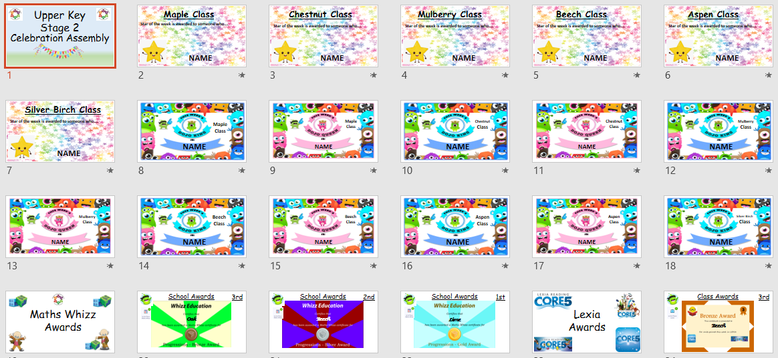

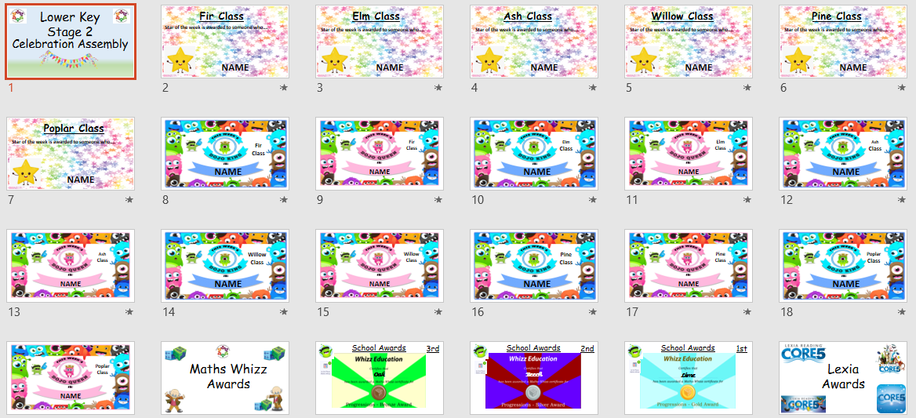

Appendix 3- positive reward overview
Day | Action | Responsible for action
Monday | - Use the dojo dashboard to award red or green dojos through the day.  - WOW dojos to be awarded to whole classes | - Class teachers  - WOW dojos- by SLT
Tuesday | - Use the dojo dashboard to award red or green dojos through the day.  - WOW dojos to be awarded to whole classes | - Class teachers  - WOW dojos- by SLT
Wednesday | - Use the dojo dashboard to award red or green dojos through the day.  - WOW dojos to be awarded to whole classes | - Class teachers  - WOW dojos- by SLT
Thursday | - Use the dojo dashboard to award red or green dojos through the day.  - End of the day, class dojos to be refreshed.  - WOW dojos to be awarded to whole classes | - Class teachers  - Class teachers  - WOW dojos- by SLT
Friday | - Reward assembly Whole school PowerPoint:-  - Dojo King & queen – named on each class slide.  - Star of the week-named on each class slide.  - Every Dojo King & Queen awarded a certificate in assembly  - Every star of the week winner to be awarded a certificate.  - Reward assembly whole school PowerPoint:-  - Maths Whizz and Lexis class winners to be announced. Winning classes to be awarded a trophy for the week.(winners from the week before, bring trophy back to assembly the following week). | - Class teachers  - Class Teachers  - SLT

Appendix 4- Red Dojos- protocol:-
Number of Reds | What we do now
5 | - 5 minutes of play missed (CT)  - Parent to be verbally informed by CT.  - CT to log the accumulation of 5 dojos on CPOMS.
10 | - Whole playtime missed (CT)  - CT to set up meeting with Parent & YGL.  - CT to log the accumulation of 10 dojos on CPOMS.
20 | - Whole lunchtime missed with SLT. (CT to inform SLT).  - CT, SLT and SENDCO to meet with parents and inform parents of child going onto a behaviour modification report.  - SENDCo to determine whether child should be included on the SEND provision list as SEMH due to behaviour proving to be a barrier to progress.  - SENDCo to undertake a SNAP behaviour assessment.  - CT to log the accumulation of 20 dojos on CPOMS.
30 | - Behaviour lead to conduct observation of child in class and break times.  - Continue to monitor behaviour modification report.  - Inclusion lead to request dowry funding for additional 121 support.  - Meeting with safeguarding team and inclusion team to discuss further tailor made support strategies.
40 | - Internal or fixed term exclusion- to be decided by SLT.

