KHastilow

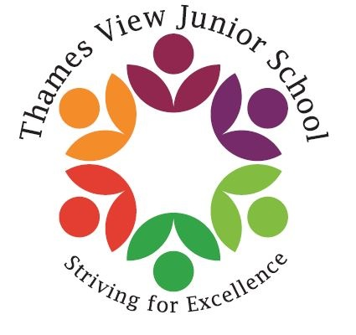

HEALTHY PACKED

LUNCH & SNACKS

POLICY

Thames View Junior School

**1. AIMS**

At Thames View Junior School, we aim to educate our children with the skills, knowledge and understanding to enable them to make informed healthy lifestyle choices. To do that effectively we need to work in partnership with parents and carers in securing the best for every child.

**Aims:**

* To ensure children have a suitable midday meal that sustains and prepares them for the afternoon learning.
* To provide a safe, healthy and appealing eating environment for pupils bringing in packed lunches and ensure that free, fresh drinking water is available at all times.
* To help children develop an understanding of healthy eating.
* To promote the School Food Trust guidelines and national standards for healthier eating.
* To support parents and carers in providing a healthy packed lunch that meets the same standards as food provided in school dinners and abide by the regulations of the British Nutrition Foundation

**2. PACKED LUNCH GUIDELINES**

The following guidelines for lunchbox contents comes from the statutory guidelines for school provided meals. This ensures equality of entitlement for all children.

The recommended contents of a healthy lunch box are:

* A good portion of starchy food e.g. bread, crackers, pasta or rice salad.
* Plenty of fruit and vegetables e.g. an apple, orange, banana, carrot sticks, small box of raisins or any other fruit or vegetable
* A portion of milk or dairy food e.g. yoghurt.
* A drink e.g. a small carton of milk, juice, squash or a bottle of water.
* One small biscuit e.g. kit-kat, penguin, club, cake bar etc. – This is equivalent to a school meal dessert
* Packed lunches should NOT include:
* Chocolate spread
* Chocolate bars
* sweets
* Fizzy drinks
* Hot food (due to health and safety guidelines)

**PLEASE DO NOT SEND YOUR CHILD WITH NUTS OR FOOD CONTAINING NUTS AS WE HAVE A NUMBER OF CHILDREN WITH SEVERE ALLERGIES**

We fully respect individual parent’s food choices for their children and understand that there are many different needs and tastes. However, if lunchbox contents regularly fall short of the expectations in this policy we will send a reminder home to parents. We want to work with parents to educate our children about healthy dietary choices so that the children, through the understanding of a balanced diet, will develop a greater appreciation of a healthy lifestyle.

**3. HEALTHY SNACKS**

If your child wishes to bring their own break time snack from home, it must be a healthy snack.

Healthy snacks can include:

* Fruit
* Vegetables
* Dried fruits
* Cereal bars – NUT FREE
* Crackers

PLEASE DO NOT SEND YOUR CHILD WITH CRISPS OR CHOCOLATE OR SWEETS

4. MONITORING ARRANGEMENTS & POLICY LINKS

This policy will be reviewed every year by the Head teacher. At every review, the policy will be shared with the full governing board.

This policy links to the following policies and procedures:

Whole School Food Policy