PSHE policy
Thames View Junior School
Author: N Pass
Sept 2022

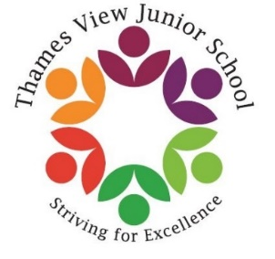

Introduction:

At Thames View Junior School we see Personal, Social, Health and Economic Education underpins all we do:

- PSHE is important and necessary part of all pupil’s education.
- The promotion of pupils’ personal development (which includes their social development) is a fundamental aspect of education and underpins all other learning.
- Through our curriculum, our school environment and our school ethos, we promote pupil’s self-esteem and emotional well-being and help them to form and maintain worthwhile and satisfying relationships based on respect for themselves and for others, at home, at school, at work and in the community.

Aims:

Through our PSHE curriculum, we aim that our pupils will:

- Develop spiritually, morally, socially and culturally
- Develop self-confidence and self-responsibility
- Value themselves and others
- Acknowledge and appreciate difference and diversity
- Be independent, responsible and active members of society
- Learn to make informed choices
- Understand their emotions
- Develop the ability to form good relationships
- Understand what constitutes a safe and healthy lifestyle
- Build their characteristics
- Promote equality

Teaching and learning

PSHE at Thames View Junior School follows the Jigsaw scheme of work. The aim of this scheme is to provide pupils with the knowledge, understanding, attitudes, values and skills they need in order to reach their potential as individuals and within the community.

Pupils are encouraged to take part in a wide range of activities and experiences across and beyond the curriculum, contributing fully to the life of their school. All subject areas may contribute to PSHE, although certain subjects may have a more significant role to play (Science, RE, PSHE). Pupils’ achievements are praised and children received rewards in a special reward assembly every Friday.
During timetabled PSHE lessons, an emphasis is placed on active learning through planned discussions, circle-time, investigations, role-play activities, group work and problem solving. All teachers will provide a safe learning environment throughout lessons. Beyond timetabled PSHE lessons, pupils are supported in applying the skills they are learning in real life situations.

Jigsaw content

Jigsaw covers all areas of PSHE from the primary phase, as the table below shows:

Term | Puzzle name | Content
Autumn 1 | Being Me in My World | Includes understanding my place in class, school and global community
Autumn 2 | Celebrating Difference | Includes anti-bullying and diversity work
Spring 1 | Dreams and Goals | Includes goal setting, aspirations, working together to design and organise events
Spring 2 | Healthy Me | Includes drugs and alcohol education, self-esteem and confidence as well as healthy life choices
Summer 1 | Relationships | Includes understanding friendship, family and other relationship, conflict resolution and communication skills
Summer 2 | Changing Me | Includes sex and relationship education in the context of looking at change

Resources

Each year group is provided with their own Jigsaw folder with teacher guideline which outlines the programme, how to deliver it and what resources are required. Teachers are provided with a Jigsaw character and the chime to assist in lessons.

Assessment

Teachers begin the topic with a baseline ‘mind map’ where teachers will gather evidence of what the children know and what needs to be developed over the half term. This will inform teachers of any additional tailoring that needs to take place. An end of half term assessment will take place, where teachers will make a decision about who has achieved the targets.
We have clear expectations of what the pupils will know, understand and be able to do at the end of each year. We have a reward assembly every week which celebrated personal achievements within school, including those of our core values: compassion, respect, perseverance, co-operation, honesty, courage.

Other Documents and Appendixes

This policy should be read in conjunction with the Teaching and Learning Policy and the National Curriculum.
Examples of class books:
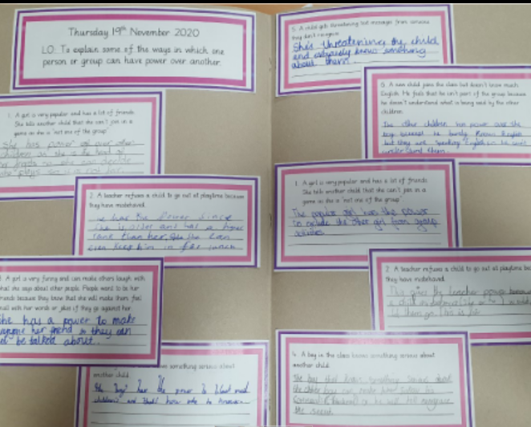
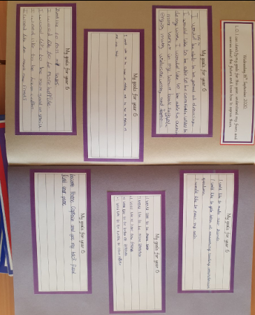

Governor Approval and Review

Confirmation that the policy for PSHE, in respect of Thames View Primary School, has been discussed, approved and ratified by the Governing Body:
Signed by: Chair of Governors: ………………………………… Date……………………………
Head Teacher: ………………………………………… Date: …………………………...
Approved at the Governing Body Meeting on: …………………………………..
Date for next review: July 2023

