Year 4 Yearly Overview 2022-2023

 | AUTUMN TERM 2022 |  | SPRING TERM 2023 |  | SUMMER TERM 2023
YEAR 4 | 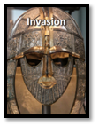 | 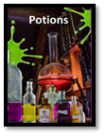 | 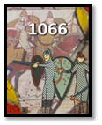 | 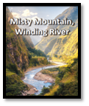 | 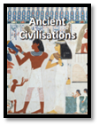
Driver | History | Science | History | Geography | History | Science
Trips |  | Science museum |  | Barking Riverside Development | Church visit | Hindu temple  National Portrait Gallery
DEAR TIME | 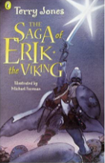 | 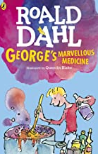 | 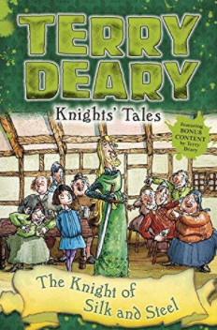 | 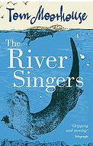 | 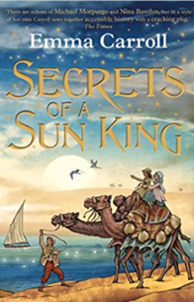 | 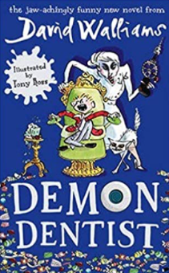
Reading | 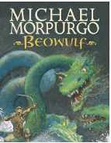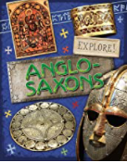 | 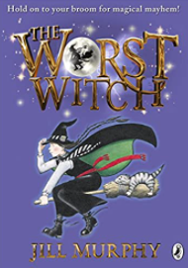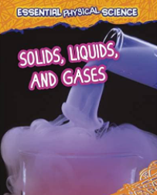 | 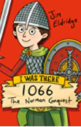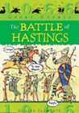 | 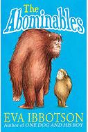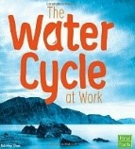 | 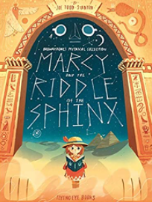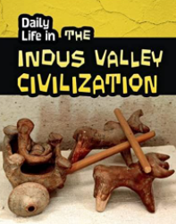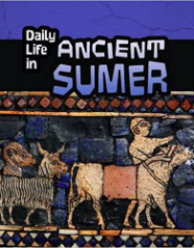 | 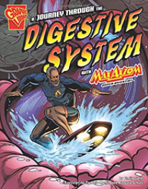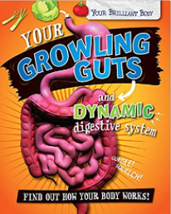
Writing | Narrative: Rumple stiltskin (T4W)  Narrative: Norse Myth (T4W)  Non Chronological Report: Anglo Saxons | Narrative: Alice’s Adventures in Wonderland (T4W)  Narrative: Tree Fall by David Weisner  Newspaper report: Missing girl | Role play and job application for King of England  Poetry: Kennings 1066 Battle weapons  Recount - Diary: Henry the Serf’s diary | Narrative: Flood by Alvaro F Villa  Persuasive text: Hill walking  Explanation text: Water cycle | Narrative: Temple Cat by Andrew Clements  Newspaper report: The Eygptian Echo  Howard Carter’s discovery  Instructions: How to mummify a body | Narrative: Journey through the Digestive System by Emily Sohm  Persduasive text: The importance of a healthy diet and exercise  Report: How does the body make poo?
Maths | Number: Place Value  Number: Addition and subtraction | Measurement: Area  Number: Multiplication and Division | Number: Multiplication and Division  Measurement: Length and Perimeter | Number: Fractions  Number: Decimals | Number: Decimals  Measurement: Money  Measurement: Time | Geometry: Shape  Statistice  Geometry: Position and Direction
Science |  | How can the states of matter make reversible and irreversible changes?  Why do liquids change shape?  What can we find out about gases?  What happens to water when it is heated? |  | Science Week - Sound |  | How are teeth structured?  How does the digestive system of humans compare to that of animals?  Science Week - Electricity
History | Why did the Anglo-Saxons invade Britain?  How would life today be different if the Anglo-Saxons had never invaded and settled in Britain?  How did the Vikings impact Britain?  Why was the reign of Athelstan significant? |  | How did the political landscape change in 1066?  What does the historiography tell us about the reaction to the Domesday Book?  What was the significance of the Norman castles? |  | How did Ancient Sumer develop?  How was society structured in Ancient Sumer?  What does the artefacts and historiography tell us about life in Ancient Egypt?  What are the distinctive similarities and differences between Ancient Sumer and Ancient Egypt?
Geography | What were the human and physical features of Anglo-Saxon settlements? |  |  | How can we describe and identify different types of mountains?  What causes flooding and how can we prevent it from seriously damaging our local area?  How polluted is the River Thames in comparison to other rivers in the UK?
PSHE | Being me | Celebrating Difference | Dreams Goals | Healthy Me | Relationships | Chaning Me
D&T |  |  | Design, make and evaluate a castle with a functioning draw bridge |  | Cooking and Nutrition  Design, make and evaluate a smoothie
Art |  | Exploring Texture  Clay Relief Tiles |  | Study of David Hockney  Landscape paintings |  | Art Week  Study of Alma Thomas  Collage
Music | Toot | Toot | Toot | Toot | Toot | Toot
R.E  What is special to me and the people in my community? | How and why do Hindus worship in the home and in the Mandir? | Why is the Bible special for Christians? | What religions are represented in our neighbourhood? | Why is Easter important to Christians? | What makes me the person I am? | What happens when someone gets married?
P.E  Class teacher  Specialist | Danish Longball | Dance- Dance around the world | Gym- Arching & bridges | Yoga | Gym- partner work- pushing and pulling | Rounders
 | OAA | Gym-Rolling & Travelling Low | Netball | Tag Rugby | Athletics | Hockey
Computing | Computing systems and networks – Connecting computers | Creating media - Audio production | Programming A – Repetition in shapes | Data and information – Data logging | Creating media – Photo editing | Programming B – Repetition in games
Spanish | Presenting myself | Family | Goldilocks | Habitats | Classroom | My home

