Year 3 Yearly OVERVIEW 2022-2023

 | AUTUMN TERM 2022 |  | SPRING TERM 2023 |  | SUMMER TERM 2023
YEAR 3 | 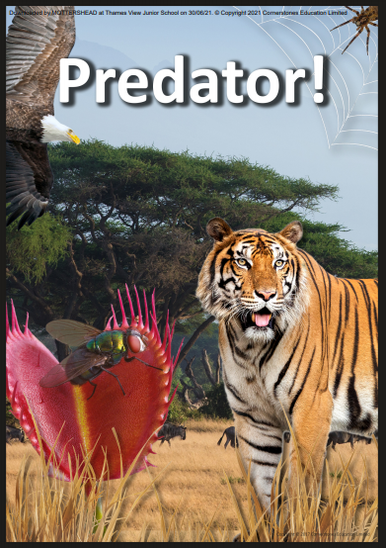 | 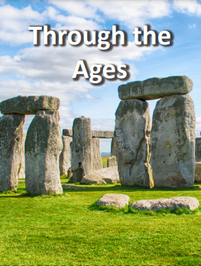 | 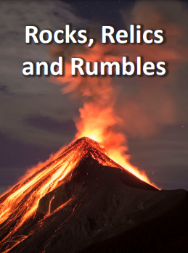 | 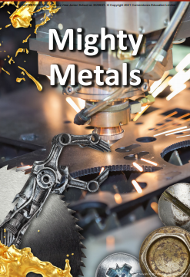 | 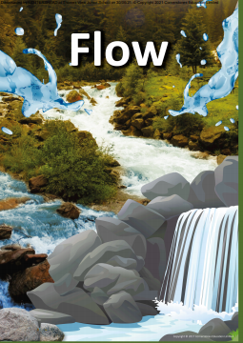 | 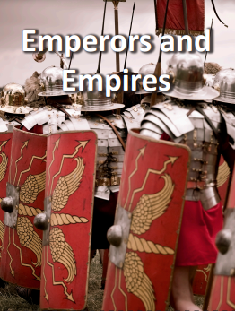
Driver | Science | History | Geography | Science | Geography | History
Trips | Eastbrookend Country Park | Barking Riverside | Visit Synagogue | D&T Week – Arbittal Mittal orbit tower | River Thames Study- Visit to Riverside | British Library
DEAR TIME | 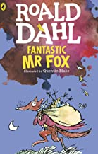 | 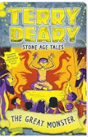 | 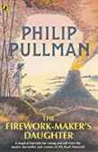 | 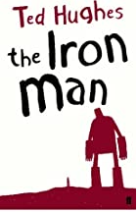 | 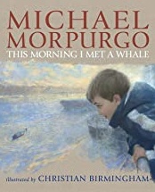 | 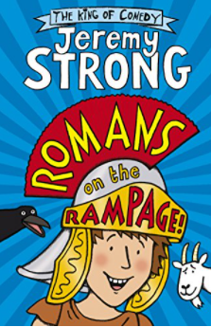
Reading | 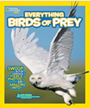  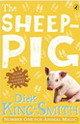 | 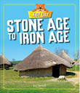  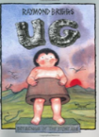  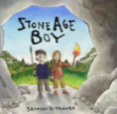 | 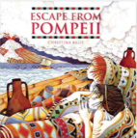  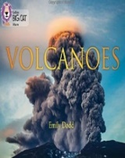 | 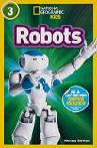  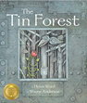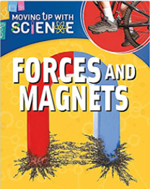 | 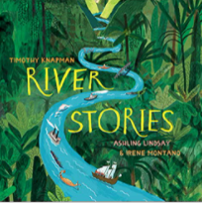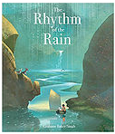  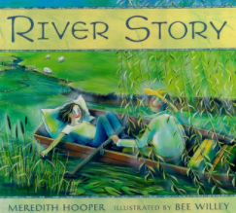 | 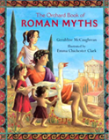  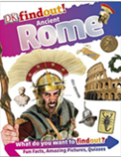
Writing | Talk for Writing-Peter and the Wolf  Information Leaflets-Birds of Prey | Talk for writing – the papaya that spoke  Talk for writing – How the world was made  Poetry – Rhyming couplets  Stone Age boy | Talk for writing: Narrative – Escape fro Pompeii  Talk for writing – What makes up the Earth  Poetry – Shape poems  Volcanoes | List poetry  Explanations – Explaning forces  Talk for writing – Narrative – The Girl and the Robot. | Talk for writing: Narrative – Flotsam.  Recount – Diary – A River  Poetry – The River | Talk for writing: Narrative – Roman Myth  Biography – Augustus  Letter – Write a letter to a Roman soldier.
Maths | Place Value  Addition & Subtraction | Addition and subtraction  Multiplication and divison A | Multiplication and Division B  Length and Perimeter | Fractions A  Mass and Capacity | Fractions B  Money  Time | Shape  Statistics
Science | ‘What would happen to a predator if their food source became scarce?’  ‘What are the different functions of flowers?’  ‘How do we identify animals?  ‘How is the cuckoo bird a parasite?’ |  | Science week- Rocks | What are forces and how do they arise?  What are the different types of forces?  What are metals and their properties?  What is magnetism and how does it work? |  | Science Week - Light
History |  | - What changes occurred in Britain during the Stone Age?  - What do the archaeological  - discoveries reveal about life in the Stone Age?  - How is the Bronze Age different from the Stone Age?  - Why was the invasion of the Celts to Britain significant?  - Why is the historical interpretation of Celtic Warriors disputed? |  |  |  | What does AD and BC stand for?  What is the history of these islands from the earliest time to present day and how have peoples lives been shaped by the events of the past?  What are the key Roman dates?  Who was Julius Ceaser and when did he invade Britain? Was he successful?  Who was emperor Claudius and how did he invade and conquer Britain.  How and when did Roman rule end in Britain?  Boudiccas rebelion and the struggle with Scottland.  Why was Hadrians wall built.  Roman inventions, towns and roads.
Geography |  |  | key aspects of physical geography, including: climate zones, biomes and vegetation belts, rivers, mountains, volcanoes and earthquakes, and the water cycle.  What are the earths four layers?  Features of a volcano.  How are natural disasters caused? |  | What are the features of a river?  How are rivers formed?  What types of plants are there in the river and how do they compare?  Water patterns  How can we interpret geographical infromation such as maps, diagrams, globes and aerial photography.  What is the water cycle?
PSHE | Being Me in My world | Celebrating Difference | Dreams & Goals | Healthy Me | Relationships | Changing Me
D&T |  |  | Design, make, evaluate and use technical knowledge to create a volcano. |  | Cooking and Nutrition  Design, make and evaluate a smoothie
Art |  | Stone Age Cave drawings  Drawing  Line and Form |  | Anish Kapoor  Sculpture  Visit to Stratford |  | Art Week – The paintings of Georgia O’Keefe
Music | Charanga Unit - R&B – Let Your Spirit Fly | Charanga Unit – Glockenspiel Stage 1 | Charanga Unit – Reggae – Three Little Birds | Charanga Unit – Friendship – The Dragon Song | Charanga Unit – Bringing Us Together | Charanga Unit – Reflect, Rewind, Replay
R.E  Big Question  How are symbols and saying important in religion? | How did Jesus and Buddha make people stop and think? | What is the significance of light? | How do Jews celebrate their beliefs at home and in the synagogue? | How and why to Hindus celebrate Holi? | What can we learn about special symbols and signs used in special religions? | What do Sikh sayings tell us about Sikh beliefs?
P.E | Teacher – Dance  PE Teacher - OAA | Teacher – Gymnastics – Symmetry and assymetry  PE Teacher - Hockey | Teacher – Gymnastics – Linking Movements  PE Teacher - Basketball | Teacher – Gymnastics – Receiving Bodyweight  PE Teacher - Football | Teacher – Athletics  PE Teacher - Cricket | Teacher – Dance – The Romans  PE Teacher - Tennis
Computing | Computing systems and networks – Connecting computers | Creating Media  Stop Frame Animation  Online Safety | Programming A  Sequence in Music | Data and Information  Branching Databases | Creating Media  Desktop Publishing  Online Safety | Programming B  Repetition in Games
Spanish | Phonetics lessons  I'm Learning Spanish | Seasons | Musical Instruments | Vegetables | Ice-Creams | Minibeasts

