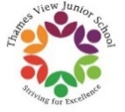

 | AUTUMN TERM 2022 |  | SPRING TERM 2023 |  | SUMMER TERM 2023
YEAR 36 | 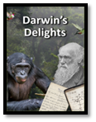 | 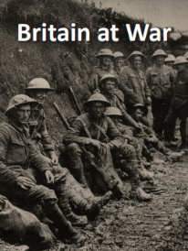 | 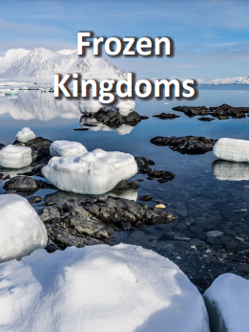 | 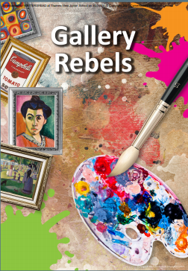 | 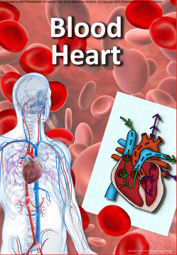 | 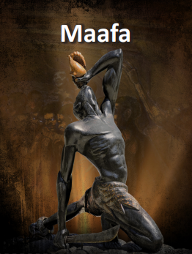
Driver | Science | History | Geography | Art | Science | History
Trips |  | Imperial War Museum | Fieldwork on the Thames | Tate Modern |  | Museum of London - London, Sugar & Slavery
DEAR | 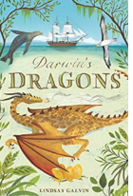 | 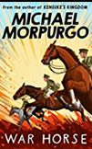 | 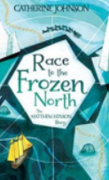 | 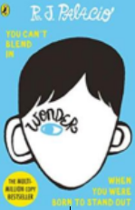 | 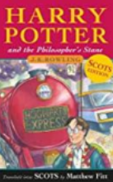 | 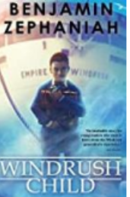
Reading | 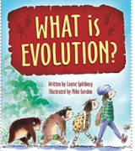  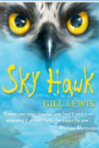 | 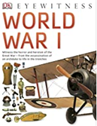  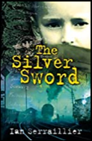 | 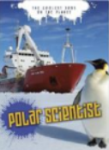  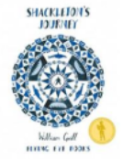 | 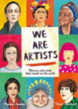  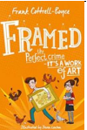 |  | 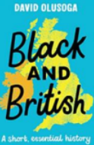  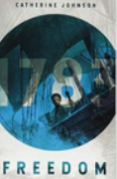
Writing | Historical narrative: Based on Stone Girl Bone Girl  Biography: Based on the text When Darwin sailed the sea by David Long | Non Chronological Reports:  Journey of a Soldier - World War 1  Historical Narrative: Based on the novel Rose Blanche | Narrative - Fairytale  The Princesses’ Blankets  Non-Fiction - Letter of Application/Diary Entries | Short Narratives – Impressionist Artists  Non-Fiction - Balanced Argument | Narrative - The Red Tree by Shaun Tan  Explanation Text - The Circulatory System | Historical Narrative-  The Village that Vanished  Newspaper Report - The Amistad Mutiny
Maths | Place Value and the four operations | Fractions and measurement
Science | - What ways do scientists prove the Theory of Evolution?  - Is the artificial selection of animals ethical?  - Fossils - what are they and what can we learn from them?  - How does the phrase ‘survival of the fittest’ relate to adaptation? |  | - What proposals can be put forward to the next UN Climate Change Conference? |  | - What are the major parts of the human circulatory system?  - Why is blood important?  - How does smoking damage your heart?  Science Week - Light | Science Week - Electricity
History |  | - What were the MAIN causes of the Great War?  - What was life like for soldiers in the Great War?  - What was the most significant factor that led to the end of the Great War?  - How did the Second World War end?  - The Battle of Britain: A turning point?  - What role did the Commonwealth play in WW2?  - How was Barking and Dagenham impacted by the two world wars? |  |  |  | - How did the transatlantic slave trade develop?  - What was the human impact of the transatlantic slave trade?  - Who were the significant figures behind the abolishment of slavery in Britain?  - Why was the Race Relations Act introduced in 1965?
Geography | - How can you the Galapagos Islands be promoted as a tourist attraction? |  | - Where are the coldest places on Earth and why are they so cold?  - How does climate change impact the Arctic and Antarctic regions?  - What is it like to live and visit the Arctic and Antarctic regions?
PSHE | - Being Me in My World | - Celebrating Difference | - Dreams and Goals | - Healthy Me | - Relationships | - Changing Me
DT |  | - Design and make an Anderson Shelter | - Design and make a stitched felt hand puppet of a polar creature |  | - Cooking and Nutrition:  Learn about make and evaluate a range of savoury and sweet bakes to sell to raise money for Year 6 Residential Trip
Art | - Beatrix Potter, Botanical Artists and Veronica Lamb: Observation Drawing – Fruit, vegetables and shells |  |  |  | - Focus on impressionist artists, such as Claude Monet. | - Study of Kehinde Wiley Self portraits
Music | Happy | Classroom Jazz 2 | A New Year Carol | You’ve Got a Friend | Music and Me | Reflect, Rewind, Replay
RE  Big question:  How important are the similarities and differences between and within religions? | - How do people express their faith through the arts in Christianity? | - What do people believe about life after death? | - What similarities and differences do religions share? | - What happened on the first Easter Sunday? | - What qualities are important to present day religious leaders? | - How could we design a celebration that involved everyone?
PE | Invasion Games | Team Building and Problem Solving  Dodgeball | Tag Rugby  Gymnastics - Counter-balance & counter tension | Gymnastics - Group Sequencing  Flag Football | Athletics  Gymnastics - Flight | Tennis  Cricket
Computing | Computing systems and networks –  Communication and collaboration | Creating media –  Web page creation
Spanish | Phonetics lesson 4 (C) & At School (P) | World War II (P) | The Weekend (P) | Regular Verbs (P) | Planets (P) | Me In The World (P)
WIDER CURRICULUM INCLUDING SCIENCE LEARNING OVERVIEW 2022-2023

