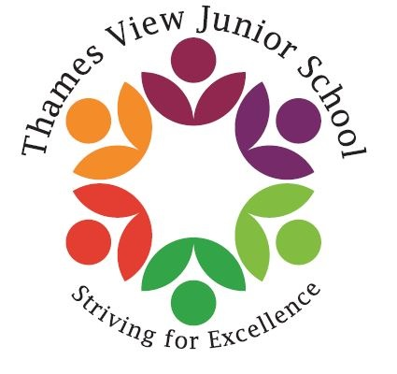
WHOLE SCHOOL FOOD
POLICY Thames View Junior School

- AIMS

At Thames View Junior school, we recognise the importance of ensuring every child has access to a healthy and well balanced diet, supporting them to lead a healthy lifestyle. We also recognise the link between a healthy diet and children’s ability to learn.

The aims of our food policy are:
- To ensure food and healthy eating messages are embedded in the school’s ethos and consistent across all food provision and classroom activities.
- To provide a whole school approach to food and healthy eating to improve the health and wellbeing of children and their families.
- To ensure a safe environment for all to explore a variety of foods, including children with dietary restrictions

2. OUR POLICY

Breakfast:
Our school has a breakfast club that runs every morning. The breakfast club is available to all pupils and costs £1.00 per day if paid in advance and £1.50 per day for any unpaid days. The food provided includes; cereals, toast, yoghurts, fresh fruit, eggs or beans & toast.
Please Note: we do require booking to be done in advance but late payment is possible.

Break Time:
If pupils are bringing snacks from home, we encourage a fruit and vegetables or a dairy portion to promote healthy snacking.

Drinks and water:
The School Food Standards recommend that drinking water should be available to all pupils, every day, and free of charge. A free supply of drinking water at lunch times to children that eat school meals and packed lunch. Water is poured for each child at lunchtime and can be refilled upon request. Drinking water is freely available all day to every child. We also have water fountains.
If pupils bring drinks in from home, sugary drinks are not permitted. Water cab be brought in a clear bottle labelled which will be stored in a designated area of the classroom. This is reflected within our healthy snacks and packed lunch policy

School meals:
Our school meals are provided by Aspens who ensure the menus are balanced and compliant with the mandatory food and nutrient based standards. Children are encouraged to choose items from the salad bar. Healthy options are promoted at lunchtime. Our dinner menu can be found on our school website.

We promote our school meals through the school website and we try to offer tasters with our menu changes.
Free school meals:
Our school also strongly encourages families to claim their free school meal (FSM) entitlement. In the school Lianne Hawkins is the key member of staff responsible for administering free school meals. Parents and pupils can speak with this member of staff about any concerns or questions they may have in confidence.
Free school meals are also included within the anti-bullying policy and payment for school meals is collected via aspens/select, rather than in classrooms, to further eliminate stigma. We make sure FSM pupils cannot be identified at any point of the school day.

Packed lunches:
Our school has a Healthy Packed Lunch & Snacks policy in place. Our policy is aligned to the same standards as those that apply to the school meals. The full policy is accessible on the school website.
The policy includes the following:
Pupils who bring in a packed lunch are able to eat in the main dining room with pupils who eat a school dinner. Parents’ will be encouraged to provide a balanced packed lunch in line with the school’s packed lunch policy. Packed lunches will be expected to include at least one piece of fruit and/or vegetables. Unhealthy snacks such as chocolate and sweets are strongly discouraged.
This is consistent with the standards for school meals. Sugary drinks are not permitted and it is not essential to bring a drink as the school provides all packed lunch pupils with access to water. Packed lunch guidance can be found on our school website.

The dining room environment:
We have a designated dining room that is an attractive and well-kept area and all pupils are able to sit with their friends during lunch. The school aims to make the dining area user friendly by monitoring noise levels, giving children the opportunity to eat food without
being rushed and providing positive messages about food.

Cultural, age appropriate, and special diets:
At TVJ we are supportive of children with any cultural and special dietary requirements and this is reflected in our food menus. All pupils’ dietary needs are recorded and communicated sensitively with the catering team. We also ensure portion sizes are age appropriate.

Sustainable, food and drink:
As a school we take pride in food culture and the environment. Our menus include locally sourced ingredients where possible and this is supported by our catering provider.

School trips and events:
Our standards of healthy eating are reflected beyond the usual school day and our food policy applies to school trips and other special events. At school discos, celebrations, and school fairs we aim provide both healthy snacks and limit unhealthy options.

The curriculum:
Our policy is reinforced and embedded through learning in the classroom. Our curriculum will enrich children’s experience of food, physical activity and healthy balanced diets through Science, PSHE, PE and Design and Technology. We build on knowledge and practical skills to support healthy choices for life beyond school.

Communication with parents:
The school is aware that the primary role model in children’s healthy eating education lies with parents/carers. We wish to build a positive and supportive relationship with the parents/carers of children at our school through mutual understanding, trust and cooperation. We will communicate and share our policy with parents each year and listen and act on views and opinions through ongoing surveys. We will inform parents/carers about the best practice known with regard to healthy eating so that the parents/carers can support the key messages being given to children at school. Parents are welcome to attend our Health and Wellbeing meetings each term when we hold an open forum to discuss any matters.

3. MONITORING ARRANGEMENTS & POLICY LINKS
This policy will be reviewed every 3 years by the Head teacher. At every review, the policy will be shared with the full governing board.

This policy links to the following policies and procedures:
Healthy Snacks & Packed Lunch Policy

